Toolbox Pencil Kit Assembly Instructions
Required Materials
- 7mm pen mandrel
- Set of Toolbox Pencil bushings
- 11 mm drill bit
- CA (cyanoacrylate) glue or two-part fast-drying epoxy
- Pen blank of choice (3/4” thickness)
- Pen press, vise, or clamp
Blank Preparation
- Cut blanks to length of brass tubes, plus an additional 1/16” on each end for squaring off
- Drill 11 mm hole lengthwise through blanks
- Rub the brass tubes with low-grit sandpaper to roughen them
- Apply a line of glue to the brass tubes and insert into the middle of the blanks with a twisting motion to spread the glue throughout the blanks
  - Ensure the inside of the tubes are free of any glue
Turning the Blank
Follow diagram A below to set up the blank on the mandrel for turning
Diagram A
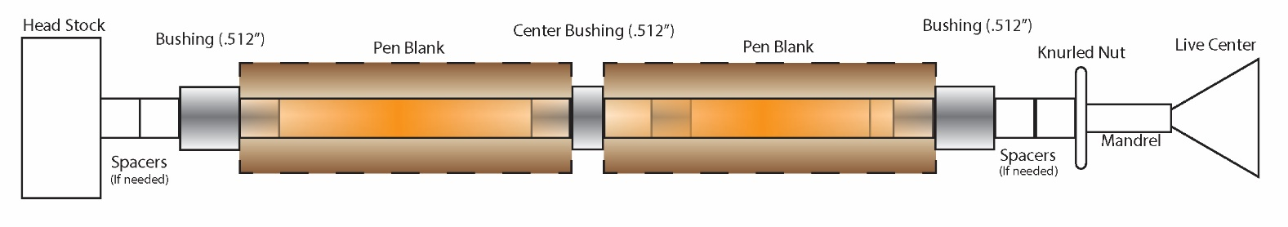
- Turn down the blank to the desired shape using lathe chisels, ensuring each end is flush with the bushings
  - Finish with sanding (wet or dry) and choice of polish

Cutting the Tenon
Part of the Upper Tube (unthreaded tube- see in Diagram B) will be stripped of the blank to allow room for the Upper Band.
- Mark the thickness of the Upper Band at the top of the Upper Tube.
- Remove the wood or acrylic above the mark using tool of choice, ensuring to leave a sharp, 90 degree corner.
Assembly
Follow diagram B below for assembly. Press parts using a pen press, vise, or clamp.
Diagram B
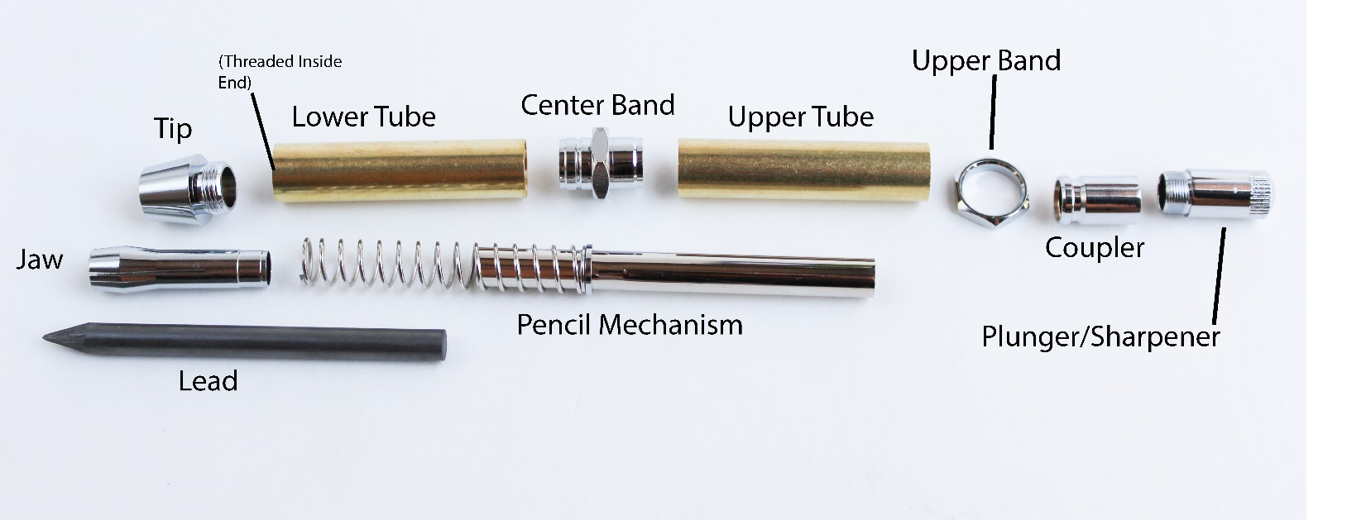
- Place the spring over the short end of the Pencil Mechanism
- Slide the Jaw into the cone end of the Tip
- Press the Jaw onto the short end of the Pencil Mechanism, compressing the spring
- Press the Center Band into the Lower Tube, ensuring not to press into the threaded side
- Press the Upper Band over the Tenon of the Upper Tube
  - If loose, a drop of CA glue may be used to secure into place
- Press the Upper Tube onto the Center Band
- Insert the Pencil Mechanism/Jaw into the Lower Tube and thread the Tip onto the Lower Tube
- Thread the Plunger/Sharpener into the Coupler
- Press the Coupler onto the Pencil Mechanism
- Push Plunger/Sharpener and insert Lead into Tip

Additional Notes
To use sharpener, unscrew the Plunger/Sharpener from the Coupler
Questions or issues? Email us at crookedmill@gmail.com

