Slimline Pen Kit Assembly Instructions
Required Materials
- 7mm pen mandrel
- Set of Slimline bushings
- 7mm drill bit
- CA (cyanoacrylate) glue or two-part fast-drying epoxy
- Pen blank
- Pen press, vise, or clamp
- Sanding supplies and finish
Blank Preparation
- Cut blank to length of brass tubes, plus an additional 1/16” on each end for squaring off
- Drill 7mm hole lengthwise through blanks
- Rub the brass tubes with low-grit sandpaper to roughen it
- Apply a line of glue to the brass tubes and insert each tube into the middle of the blanks with a twisting motion to spread the glue throughout the blank
  - Ensure the inside of the tubes are free of any glue
- Square off the ends of each blank with a barrel trimmer or sander to be flush with the brass tube
Turning the Blank
Follow diagram A below to set up the blank on the mandrel for turning
Diagram A
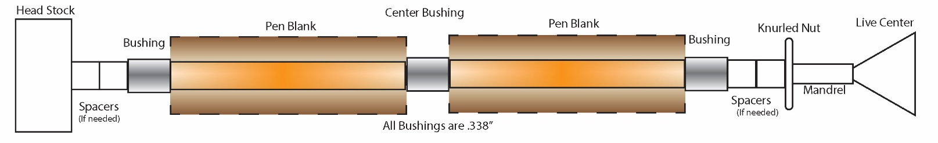
- Turn down the blank to the desired shape using lathe chisels, ensuring each end is flush with the bushings
  - Finish with sanding (wet or dry) and choice of polish
Assembly
Follow diagram B below for assembly. Press parts using a pen press, vise, or clamp. Please note that the Lower Tube and Upper Tube are identical- select one to be the Upper, and one to be the Lower.
Diagram B
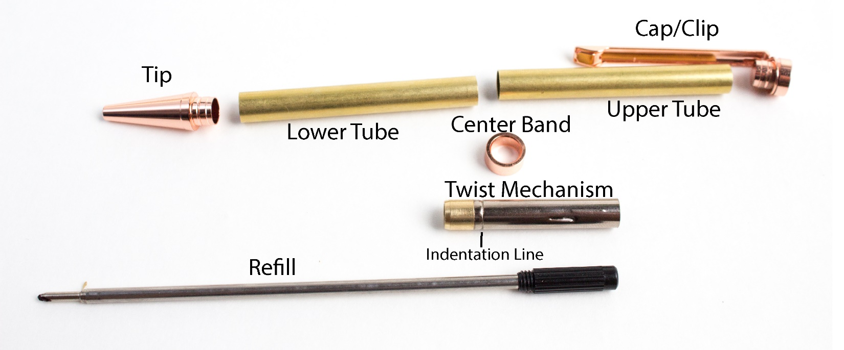
- Press the Tip onto the Lower Tube
- Press the Twist Mechanism onto the opposite end of the same Tube to the Indentation Line
- Place the Center Band over the top of the Twist Mechanism
- Insert the Refill through the Twist Mechanism and screw into place
- Press the Cap with Clip into one end of the Upper Tube
- Press the two halves together until snug

Questions or issues? Email us at crookedmill@gmail.com

