Marchesa Pen Kit Assembly Instructions
Required Materials
- 7mm pen mandrel
- Set of Marchesa bushings
- 7mm drill bit
- CA (cyanoacrylate) glue or two-part fast-drying epoxy
- Pen blank
- Pen press, vise, or clamp
- Sanding supplies and finish
Blank Preparation
- Cut blank to length of brass tube, plus an additional 1/16” on each end for squaring off
- Drill 7mmhole lengthwise through blank
- Rub the brass tube with low-grit sandpaper to roughen it
- Apply a line of glue to the brass tube and insert tube into the middle of the blank with a twisting motion to spread the glue throughout the blank
  - Ensure the inside of the tube is free of any glue
- Square off the ends of each blank with a barrel trimmer or sander to be flush with the brass tube
Turning the Blank
Follow diagram A below to set up the blank on the mandrel for turning
Diagram A
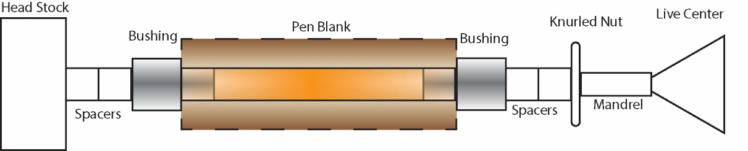
- Turn down the blank to the desired shape using lathe chisels, ensuring each end is flush with the bushings
  - Finish with sanding (wet or dry) and choice of polish
Assembly
Follow diagram B below for assembly. Press parts using a pen press, vise, or clamp.
Diagram B
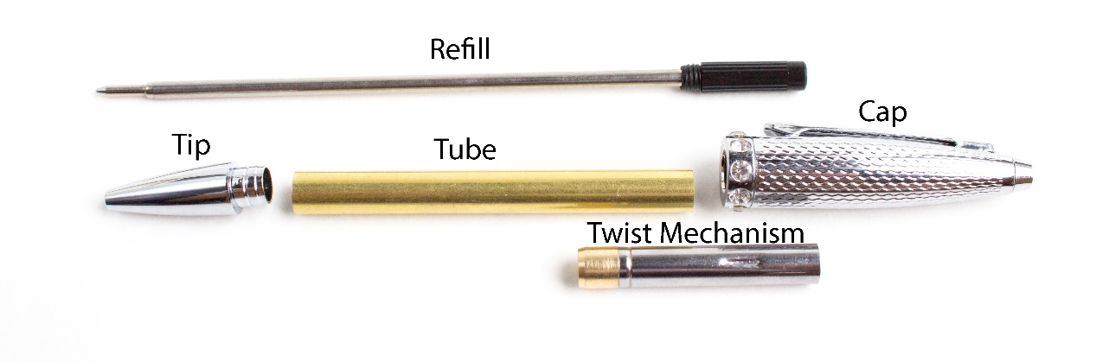
- Press Tip onto one end of the Tube
- Press the Twist Mechanism (brass end first) until the indentation line onto the opposite end of the Tube
- Insert the Refill through the Twist Mechanism and screw into place
  - Test for extension, and press the Twist Mechanism further as needed (with the Refill removed)
- Press the Cap onto the Twist Mechanism
Other Info
- Refill may be replaced by pulling off the Cap

Questions or issues? Email us at crookedmill@gmail.com

