Magnetic Pen Kit Assembly Instructions
Required Materials
- 7mm pen mandrel
- Set of Magnetic Pen bushings
- 10.5mm drill bit
- CA (cyanoacrylate) glue or two-part fast-drying epoxy
- Pen blank
- Pen press, vise, or clamp
- Sanding supplies and finish
Blank Preparation
- Cut blank to length of brass tube, plus an additional 1/16” on each end for squaring off
- Drill 10.5mm hole lengthwise through blank
- Rub the brass tube with low-grit sandpaper to roughen it
- Apply a line of glue to the brass tube and insert into the middle of the blank with a twisting motion to spread the glue throughout the blank
  - Ensure the inside of the tube is free of any glue
- Square off the ends of each blank with a barrel trimmer or sander to be flush with the brass tube
Turning the Blank
Follow diagram A below to set up the blank on the mandrel for turning
Diagram A
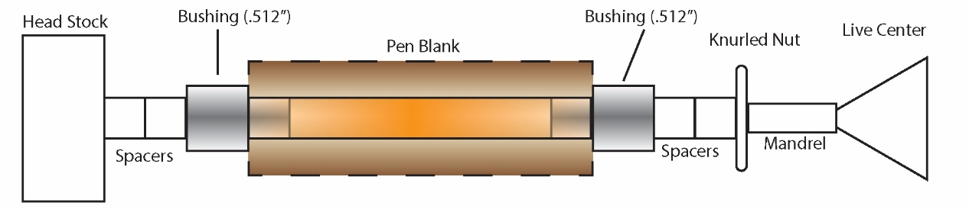
- Turn down the blank to the desired shape using lathe chisels, ensuring each end is flush with the bushings
  - Finish with sanding (wet or dry) and choice of polish
Assembly
Follow diagram B below for assembly. Press parts using a pen press, vise, or clamp.
Diagram B
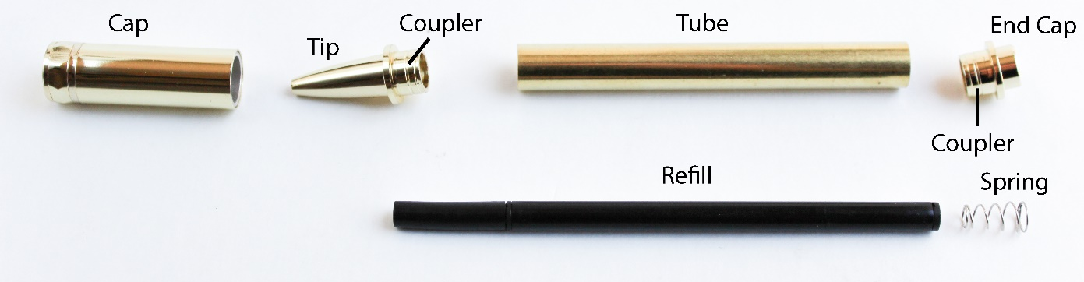

- Unscrew the Couplers from the Tip and the End Cap
- Press each Coupler into opposite ends of the Tube
- Screw the End Cap onto the Coupler
- Pull the cover off the Refill. Insert the Spring then Refill into the Tube (the Spring should sit with the wider part near the End Cap)
- Screw the Tip onto the other Coupler
Other Info
- To replace Refill, simply unscrew the Tip from the Coupler

Questions or issues? Email us at crookedmill@gmail.com

