Gear Click Pen Kit Assembly Instructions
Required Materials
- 7mm pen mandrel
- Set of Gear Click Pen Kit bushings
- 3/8” drill bit
- CA (cyanoacrylate) glue or two-part fast-drying epoxy
- Pen blank
- Pen press, vise, or clamp
- Sanding supplies and finish
Blank Preparation
- Cut blank to length of brass tube, plus an additional 1/16” on each end for squaring off
- Drill 3/8” hole lengthwise through blank
- Rub the brass tube with low-grit sandpaper to roughen it
- Apply a line of glue to the brass tube and insert tube into the middle of the blanks with a twisting motion to spread the glue throughout the blank
  - Ensure the inside of the tube is free of any glue
- Square off the ends of each blank with a barrel trimmer or sander to be flush with the brass tube
Turning the Blank
Follow diagram A below to set up the blank on the mandrel for turning
Diagram A
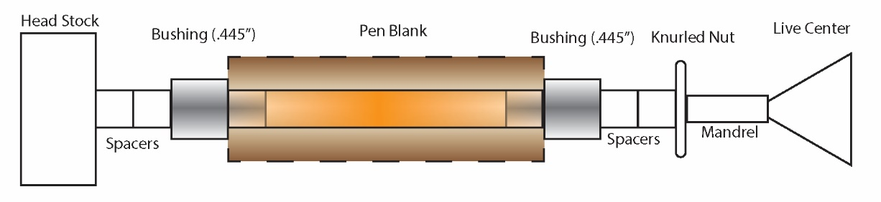
- Turn down the blank to the desired shape using lathe chisels, ensuring each end is flush with the bushings
  - Finish with sanding (wet or dry) and choice of polish
Assembly
Follow diagram B below for assembly. Press parts using a pen press, vise, or clamp.
Diagram B
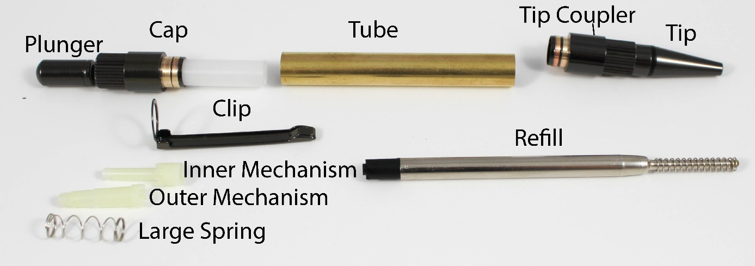
- Unscrew the Tip Coupler from the Tip and press one end of the Tube onto the Tip Coupler
- Place the Outer Mechanism over the Inner Mechanism so that the teeth of both pieces interlock
- Insert this piece into the white plastic end of the Cap (threaded end first)
- Place the Clip onto the Cap and press this assembly onto the other end of the Tube
- Place the small spring over the Refill and insert through the Tip Coupler
- Screw the Tip back onto the Tip Coupler
- Place the Large Spring into the Cap
- Screw the Plunger onto the Cap, over the Large Spring

Other Info
To replace the Refill, simply unscrew the Tip

Questions or issues? Email us at crookedmill@gmail.com

